SSIP 2.0 2 Days Bootcamp on Future-Ready Engineers: Agentic AI & Automation

- Event Name: | 2 Days Bootcamp on Future-Ready Engineers: Agentic AI & Automation
- Date: | 6th & 7th January 2026
- Venue/ Mode: | Room No. 141, ADIT, The CVM University (Offline)
- No of Participants: | 51
- Speakers/Coordinator Name | Industry Experts: Mr. Kanti Patel (Founder, Intency Technologies),  Mr. Parth Kanani  Faculty Coordinators: Dr. Krunal Patel, Dr. Trilok Suthar
6. About Event: | The Department of Information Technology, A. D. Patel Institute of Technology (ADIT), organized a 2-Day Bootcamp on “Future-Ready Engineers: Agentic AI & Automation” under SSIP 2.0. The objective of the bootcamp was to provide students with hands-on exposure to Agentic AI, automation using n8n, and real-world industry use cases. The sessions were conducted by industry experts from Intency Technologies, Ahmedabad. Students actively participated in practical demonstrations, workflow development, and group-based activities, making the event highly interactive and industry-oriented.
7.Outcome of Event: | • Enhanced understanding of Agentic AI and automation concepts.  • Practical exposure to n8n automation workflows and cloud deployment.  • Improved problem-solving, teamwork, and industry readiness.  • Strengthened industry–academia collaboration.  • Encouraged innovation-driven learning among students.
8.Event Photograph (with Geotag)
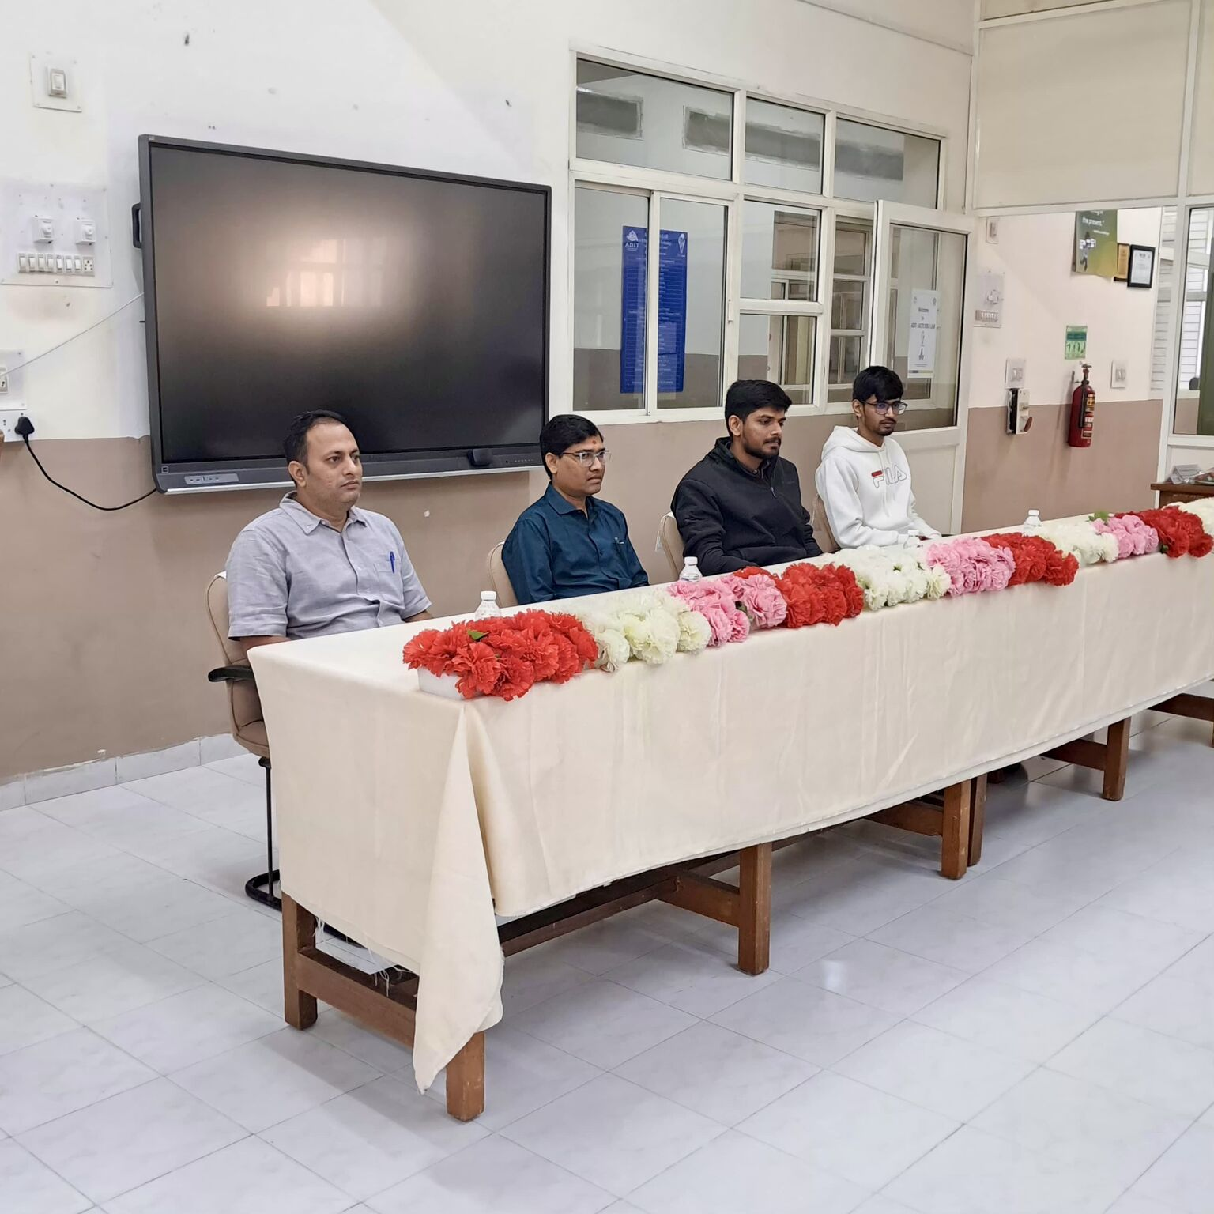  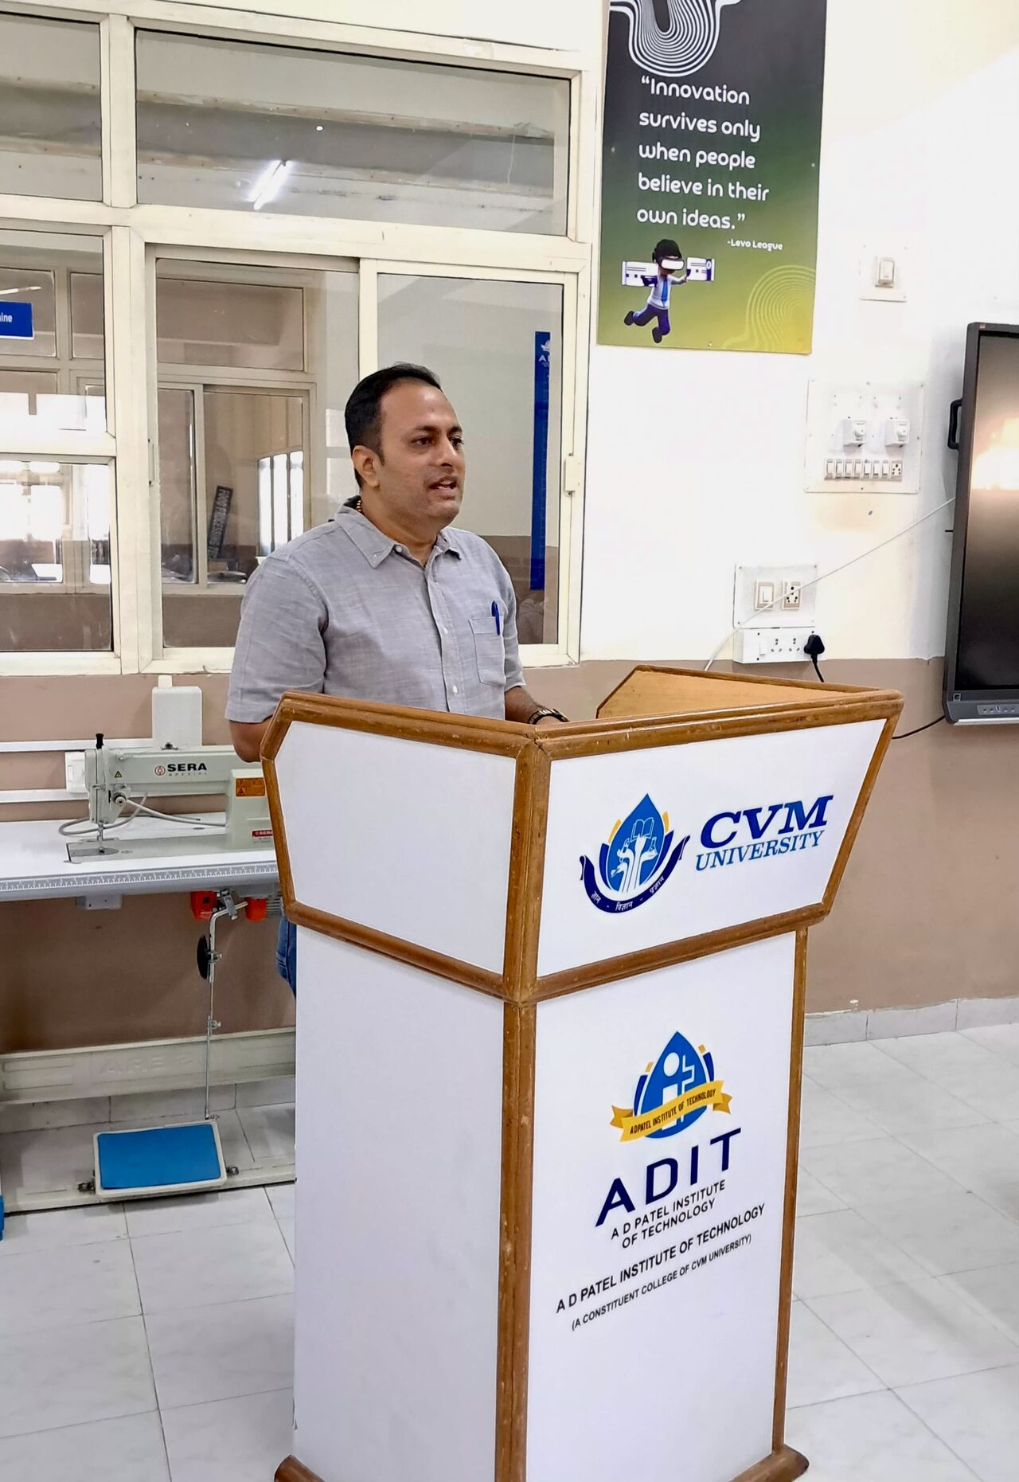 |  | 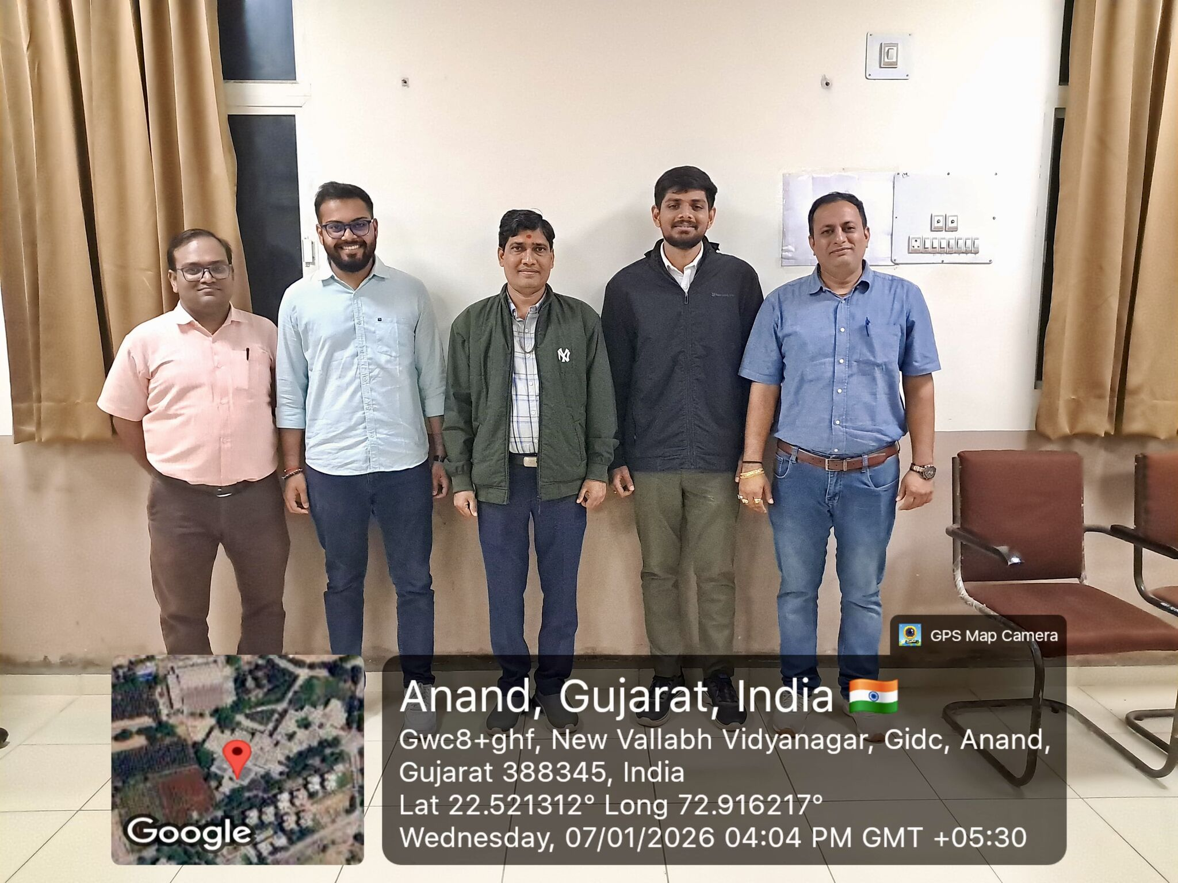  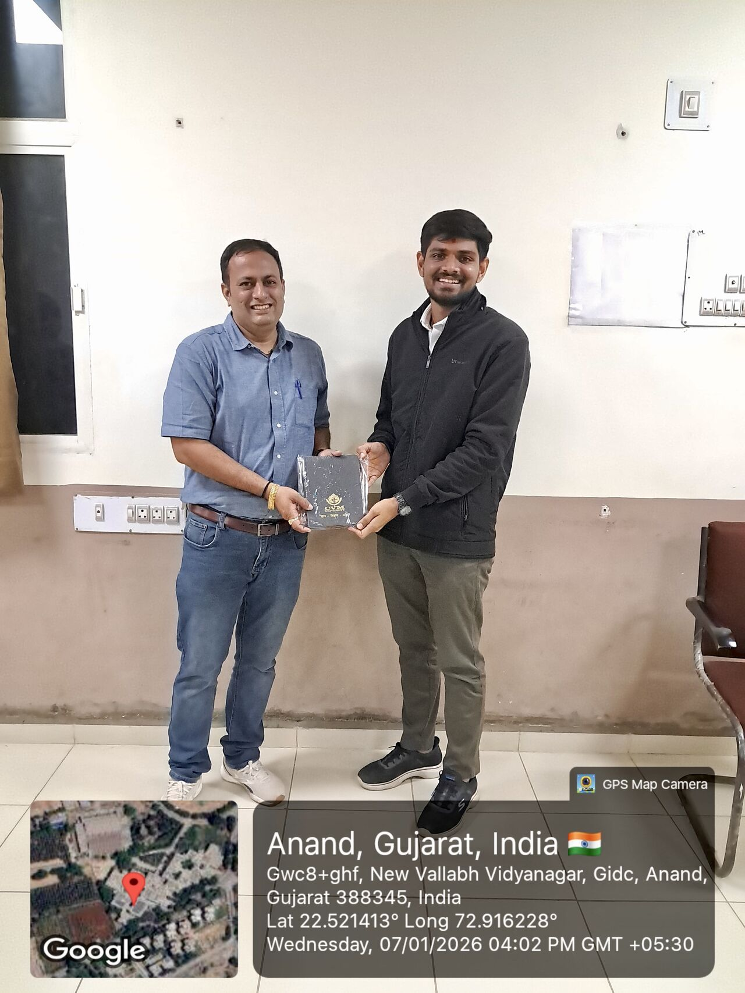
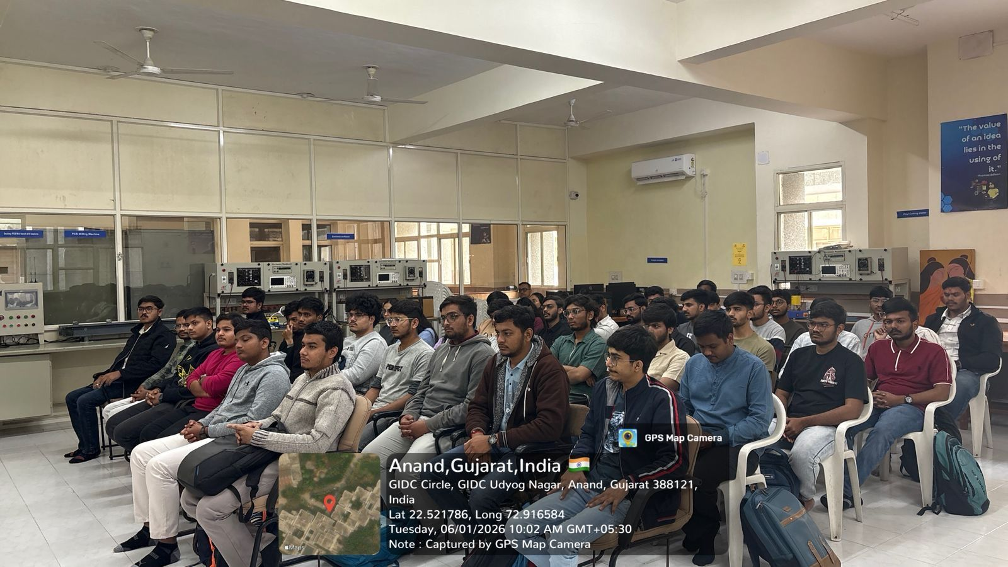
9.Signature of Coordinator and Stamp:

Dr. Krunal Patel
Dr. Trilok Suthar

